HIZAR ALAM 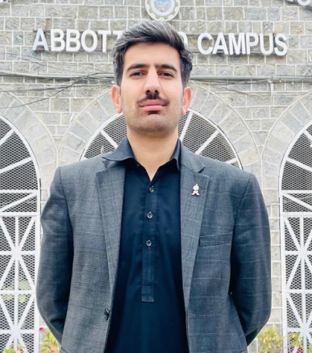

(Civil Engineer)
Email (Personal): hizeralam7555@gmail.com
(Official): hizeralam7555@gmail.com

CELL# +92-3022334785 (PAK)

Country of Stay: PAKISTAN
Nationality: PAKISTAN

Personal Statement:
I am a self-motivated and energetic “Civil Engineer”, recently graduated from UET Peshawar. in depth knowledge of different aspects of geotechnical engineering, transportation engineering, urban planning, and construction management .; been involved in practice in the field with studies.; well versed in various reporting systems and related software like Excel, Revit, SAAP, Primavera P6, ArcGIS and MS- Project etc.

A C A D E M I C Q U A L I F I C A T I ON

B.Sc: Civil engineering (2020 -24) University Of Engineering And Technology Peshawar

H O B B I E S

Studying books

Playing cricket and football.

Gyming

Movies

Professional Training & Certifications:

- Three months internship at m/s tikri construction company.
- Site survey of township Abbottabad by university of engineering and technology Peshawar.
- Worked on numerical modeling of mechanically stabilized earth wall in final year project.

